|  |
| --- |
| $EXPORT_TITLE$ |
| $EXPORT_PERIOD$ |

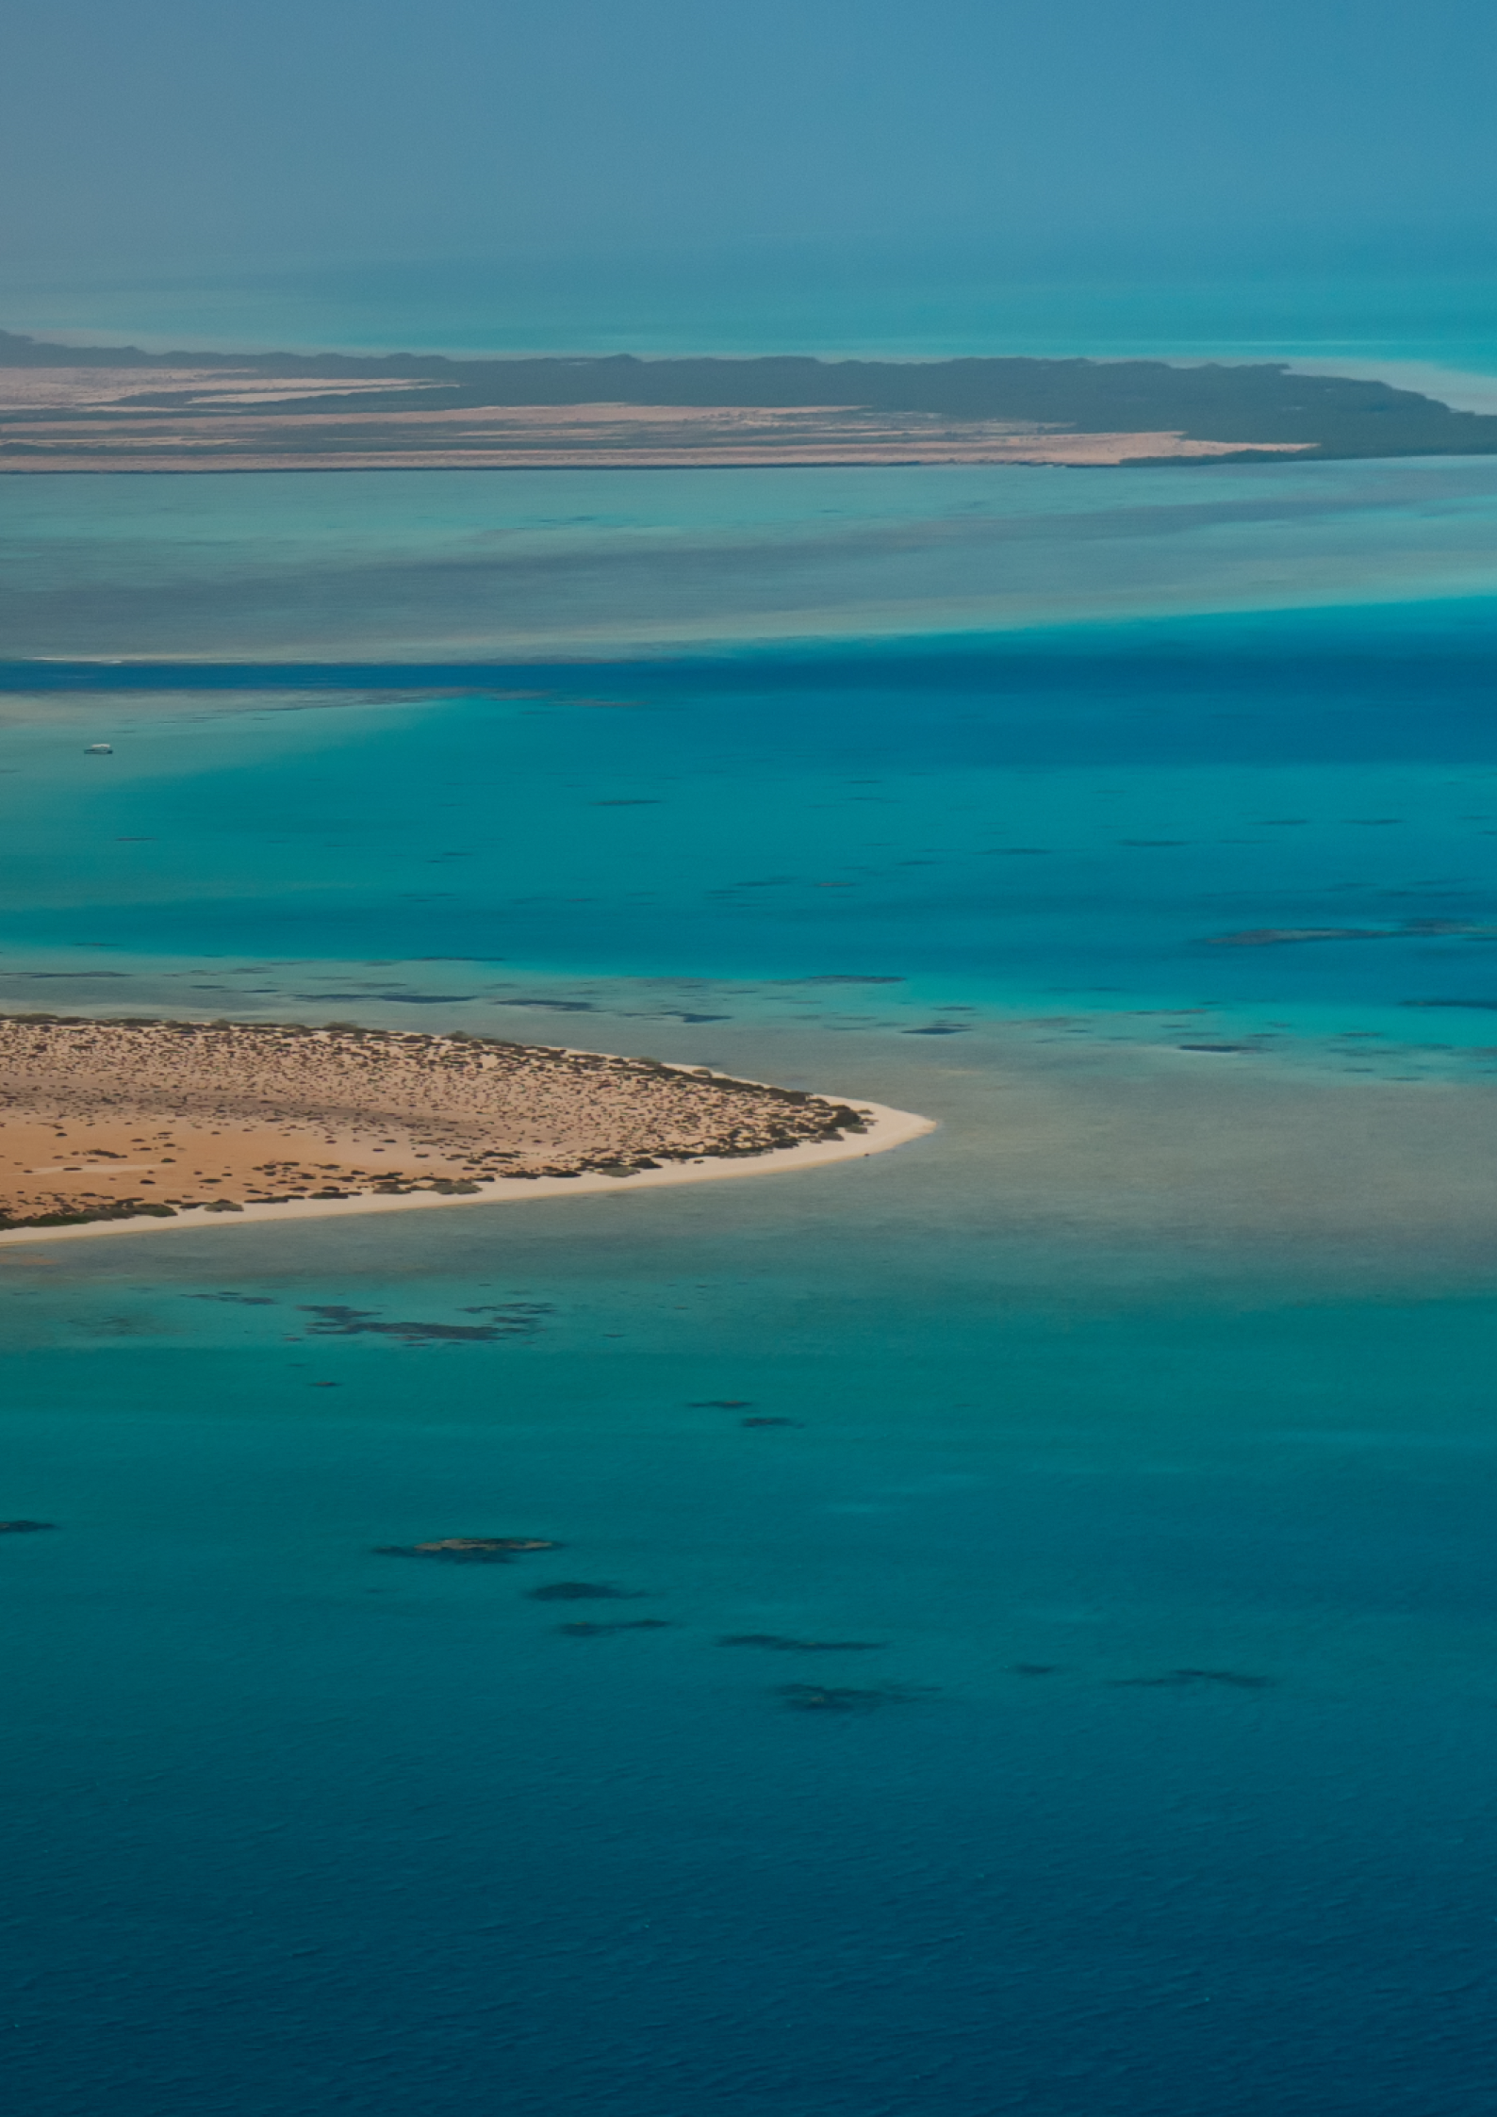

| Table of contents |
| --- |
|  |
| $EXPORT_TOC$ |